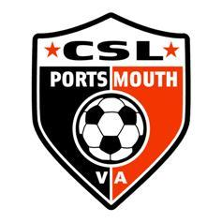
Churchland Soccer League, Inc.

Playing Different Age Group

Churchland Soccer League (CSL) forms all teams at all tiers of play (Recreation, Advanced, and Travel) in accordance with the age groups as follows; birthdays between August 1st of a year through July 31st of the following year are grouped as an age-group.

As an example, a player that is 11 (under 12 years of age before August 1st) prior to the upcoming season in which they will participate is a U12 player and remains in the U12 age-group for the entire year (both Fall and Spring seasons). If a player’s birthday is on August 1st they are considered a U13 player.

CSL reserves the right to combine age-groups. CSL recognizes these age groups as established and expects teams to be formed in “true age-group fashion”. This means that if a team is to be registered as a U12 team then the age of the players is expected to be U12 aged players. No over-age player may be rostered to an under-age team; therefore as an example, no U13 aged player may be rostered to a U12 team. There is no “playing-down” in age groups or any tier of play.

Within the Recreational tier of play, CSL does not support “playing-up” in age groups.

Within the Advanced and Travel tiers of play, “Playing up” is permitted only with the permission of the Technical Director and, if approved, will not exceed more than one year of an age-group.

